
If London Were Syria
This powerful short clip was created by Don’t Panic London for Save The Children UK, to mark the third anniversary of the Syrian Civil War, and aimed to improve the lives of children in Syria and around the world. The video went viral and listed as one of the most successful fundraising videos for charity in 2014, reaching nearly 60 million views. This led to a dramatic increase of donations of about 25% in the first week. The goal was to raise public awareness of the suffering of refugees who might otherwise have been ignored.

Why is it so powerful?
Firstly, the title itself is persuasive and catches your eye – in other words, it’s “clickworthy”. ‘Most Shocking Second a Day Video’ is ambiguous and creates a curiosity gap by providing just enough information to make people want to click to know more.

Representation
Research has found a message to be more effective if the recipient perceives themselves as similar to the source. The mundane, normal activities of an average British person is shown in the girl playing with make-up, learning the recorder and playing in the park, which reflect similar childhood activities in many of the audience – we can identify with her, therefore the ad has greater impact.
Making the child British, encourages us to view Syrian children to be similar. This video allows our in-group to increase in size, by showing that people in Syria are human too and not so different from ourselves. This therefore allows us to feel more engaged with the girl, to empathise with her, and we are therefore more likely to donate.
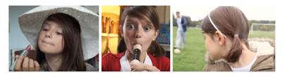
Perspective Taking
The video’s alternative title ‘If London were Syria’ reflects its simple but impactful premise – ‘imagine if we ourselves were the refugees?’. This video brings the war to a familiar ground, making it more relatable to the viewer. Subverting the norm by using a British girl as the protagonist and London as the setting creates a personal connection and relevance to the viewer. This allows us as viewers to easily empathise and see the perspective of the young girl.
Narrative
The ad gives a narrative that provides a causal structure to how one girl’s life changes dramatically. The story has a strong emotional hook, and an open-ended narrative which leaves you feeling uncomfortable without clear closure. The safety of the girl’s life is uncertain – much like the safety of Syrian refugees now. We are taken through snippets of the girl’s journey day by day. Storytelling has been found to be effective in inducing emotion, and emotion has been linked with better recall, i.e. the audience will remember this ad, which helps influence their attitudes and behaviours. We are emotionally invested in this girl’s story.
Emotional see-sawing is a technique used in the ad, underlined by the binary oppositions where we see the girls experience change quickly from positive to negative. This dramatic change in emotion has been found to increase compliance, and thus donations to the charity. The story also has a cyclical feel, as it begins and ends on making a wish on her birthday, showing a contrast not only in her emotions, but physically in the candles reducing and lack of family.
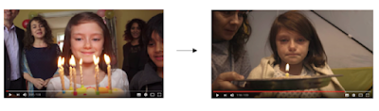
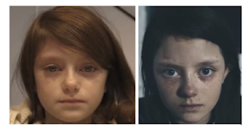
Addressing YOU directly
The ad ends with the girl hauntingly looking directly at the camera, as if she is looking to you for help personally. Eye contact is a powerful technique to connect with the viewer, and creates personal involvement, increasing the likelihood of processing information through the central route (Petty, Cacioppo & Schumann, 1983). At the end of both ads she looks up after blowing out her candle and makes a wish – a wish for you to help her.

